**HR Attrition SQL Queries**

**KPI’s**

**1. Employee Count :**

select sum(employee_count) as Employee_Count from employees;

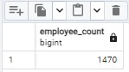

**2. Total Attrition :**

select count(attrition) from employees where attrition='Yes';

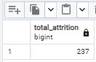

**3. Active Employees :**

select sum(employee_count) - (select count(attrition) from hrdata where attrition='Yes') from employees ;

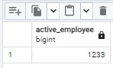

**4. Average Age :**

select round(avg(age), 0) from employees;

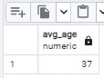

5**. Attrition Rate**

select

round (((select count(attrition) from employees where attrition='Yes')/

sum(employee_count)) * 100,2)

from employees;

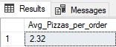

**B. Attrition by Gender**

select gender, count(attrition) as attrition_count from employees

where attrition='Yes'

group by gender

order by count(attrition) desc;

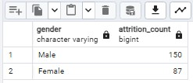

**C. Departmentwise Attrition**

select department, count(attrition), round((cast (count(attrition) as numeric) /

(select count(attrition) from employees where attrition= 'Yes')) * 100, 2) as pct from employees

where attrition='Yes'

group by department

order by count(attrition) desc;

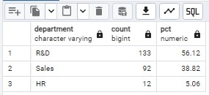

**D. Attrition according to Education**

select education_field, count(attrition) as attrition_count from employees

where attrition='Yes'

group by education_field

order by count(attrition) desc;

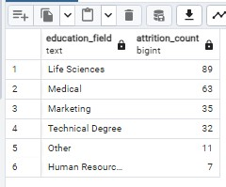

**E. Number of Employee by Age group**

Select age, sum(employee_count) as employee_count from employees

group by age

order by age;

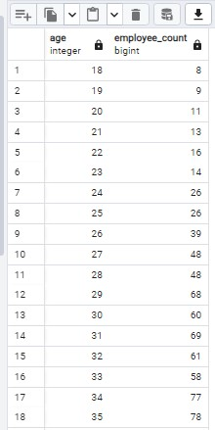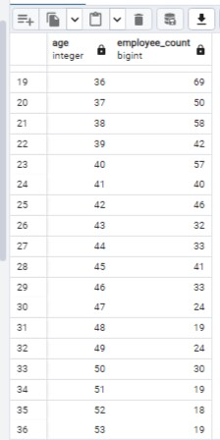

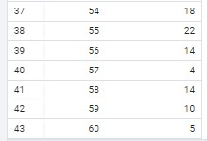

**F. Job Satisfaction Rating**

-Run this query first to activate the cosstab() function in postgres

CREATE EXTENSION IF NOT EXISTS tablefunc;

-Then run this to get o/p-

SELECT *

FROM crosstab(

'SELECT job_role, job_satisfaction, sum(employee_count)

FROM employees

GROUP BY job_role, job_satisfaction

ORDER BY job_role, job_satisfaction'

) AS ct(job_role varchar(50), one numeric, two numeric, three numeric, four numeric)

ORDER BY job_role;

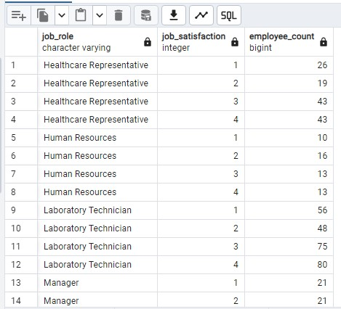  
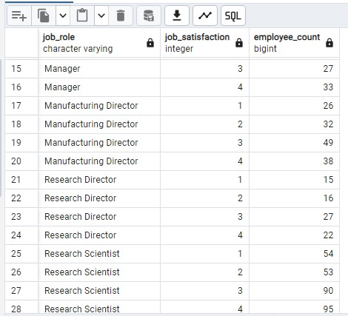

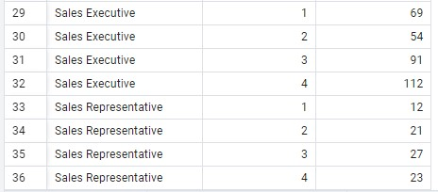

**G. Attrition rate by Gender for different Age & Gender**

select cf_age_band, gender, count(attrition) as attrition,

round((cast(count(attrition) as numeric) / (select count(attrition) from employees where attrition = 'Yes')) * 100,2) as pct

from employees

where attrition = 'Yes'

group by cf_age_band , gender

order by cf_age_band, gender desc;



**H. Total employee by Department & Job role**

Select job_role, department, COUNT(employee_number) as total_employees

From employees

GROUP BY job_role, department

ORDER BY job_role, department;

